**ARC application guideline**

1. Receiving Units: Southern Taiwan Joint Services Center/ Kaohsiung City First Service Center, National Immigration Agency

*→information below is the map/QR code of this center.*

1. Office site: 5 & 6 FL.,NO.6 Zhengnan St, Lingya Dist, Kaohsiung City, Taiwan (R.O.C.)
2. Required documents (verify the original and take its copy):

* A completed application form: [http://ciae2.kmu.edu. tw/images/doc_download_Arrival_in_Taiwan/ARC.pdf](http://ciae2.kmu.edu.tw/images/doc_download_Arrival_in_Taiwan/ARC.pdf)

*→or you can scan the QR code below.*

* A passport with resident visa.( A foreign national applying for modifications in the reasons for residency pursuant to Paragraph 2 of Article 23 of the Act, is exempt from being examined for an entry visa)
* Related documents for residency (Studying): A Student ID Card with Registered Stamp(在學證明印章).

*→[NOTICE] Bring your photo copy of Stu. ID card to the academic office, ask them put the Registered Stamp(在學證明印章) on it.*

* One 2’’x 2’’ colored photo, front head and shoulder, taken within six months.
* A foreign national who applies for an ARC reissuing shall submit Declaration of Loss of ARC or a Crime Report

1. Fees for applying: NT1,000. (for 1 year)
2. Processing time: 10 workdays

**[NOTICE]**

**(1)bring the receipt when you go to receive the ARC**

**(2)Freshmen require to complete the ARC application within 15 days of the arrival in Taiwan.**

↓Directon: Take the MRT to the City Council Station→go to the Exit1→follow the map below to the Kaohsiung City First Service Center(Kaohsiung Immigration Office)

The map of Southern Taiwan Joint Services Center

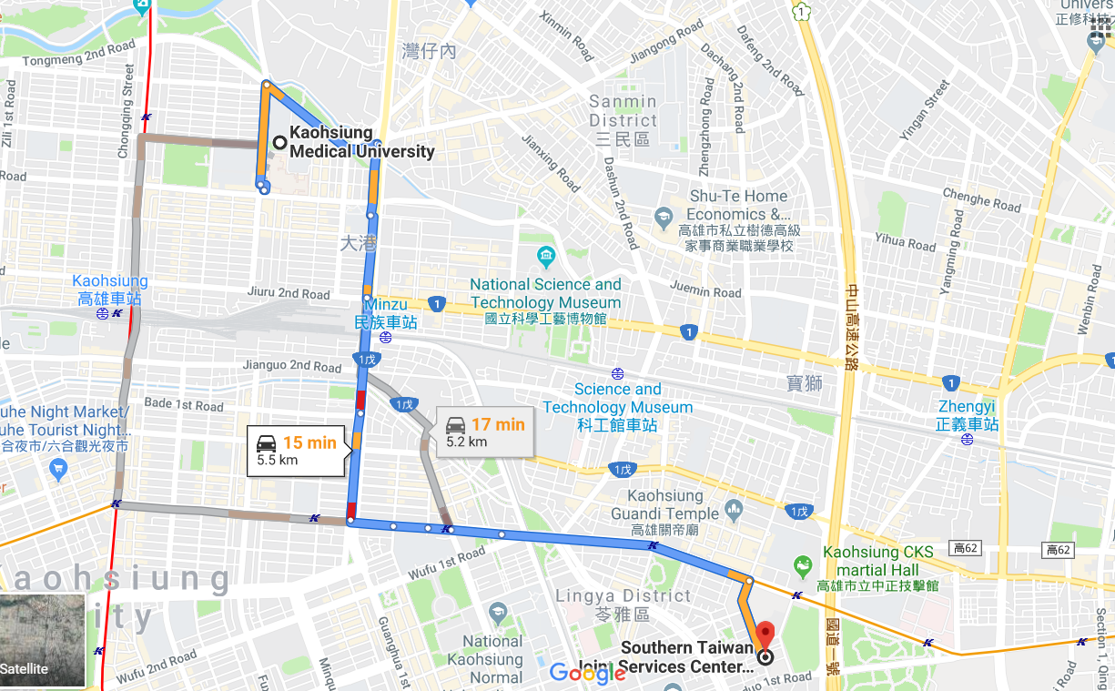



The application from of ARC